**20 July**

Main.provider.tf

main.tf ke andar variable daalaa thaa

Types of variable – Primitive and Advanced

Primitive variable banana ke liye use kre – String, Boolean, Numbers

Now if we have to make many rgs so repetition is not good practice so list came.

**+++++++++++++++++++++++++++++++++++++++++++++++++++++++++++++++++++++++++++++++++**

1) List – Collection of same kind of attributes (like name and location) is called List

2) List is useful – when we have to create **10 or multiple resource groups** only in one region like WestEurope. So to overcome this problem **map** used to come in market

3) What is **For each** – For each creates all the resource groups that we provide in the list means it reads every element in the given list and then creates resource blocks for the given number of elements. For eg – rg1, rg2, rg3, rg4 as shown below

4) What is **set** – Set is used to remove duplicacy of the elements given in the list ie every element is unique. As 2 rgs with same name cannot be created at the same time, otherwise our code will not work.

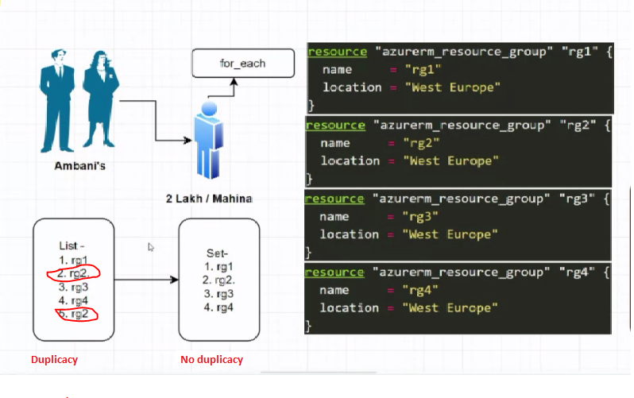

**+++++++++++++++++++++++++++++++++++++++++++++++++++++++++++++++++++++++++++++++++**

***AGENDA – Pehle set se krke dekhte hai***

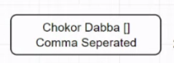

Chokor dibbe ke andar by default list hota hai as per terraform

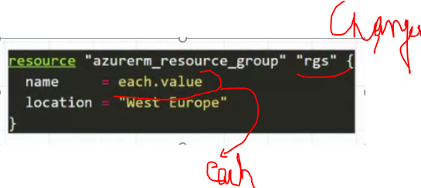

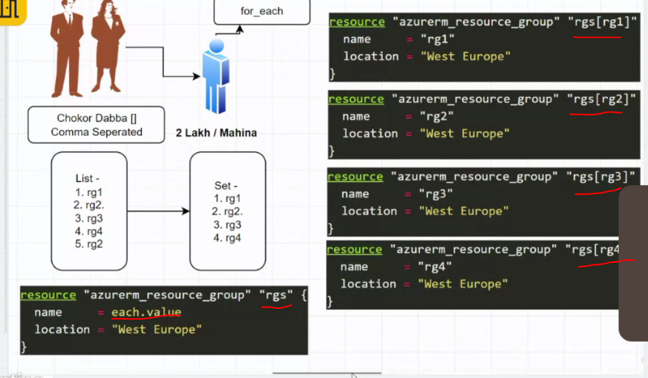

4) **For each** always goes inside **resource block –> mug up**

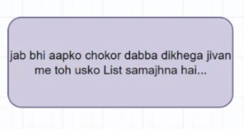

As per above statement Whenever we will any array (chokor dabba) then terraform will consider it as list. But for considering it as set we have explicitly define the set().

5)

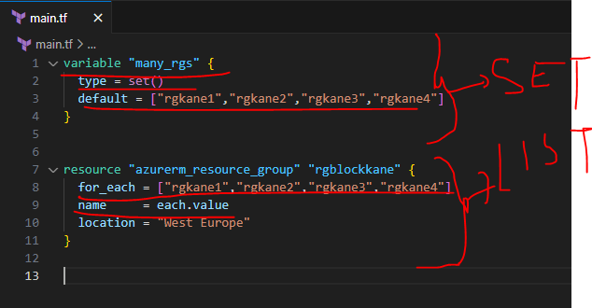

6) In [] content is considered as list but as per doc, terraform understands set of strings not list then conflict is there

7)

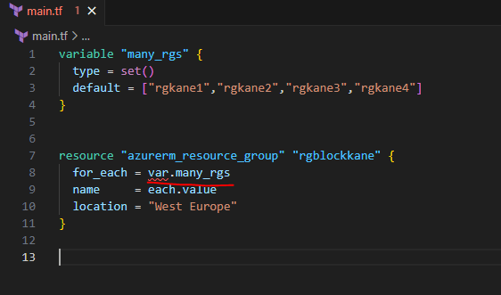

8) **terraform init**

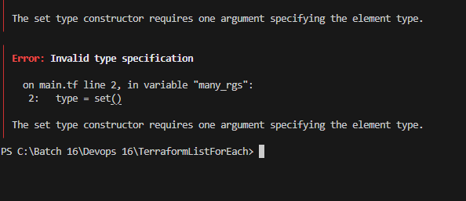

So above error means we have to define element type inside set ()

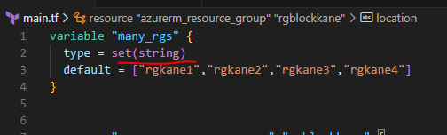

**terraform validate**

**terraform fmt**

**az login**

**terraform plan**

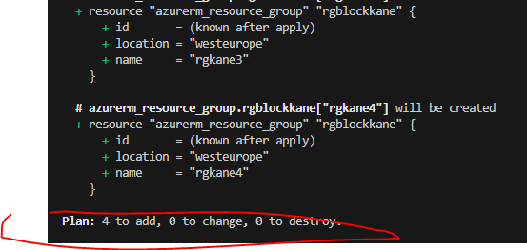

++++++++++++++++++++++++++++++++++++++++++++++++++++++++++++++++++++++++++++++++++

**AGENDA – Agar set ki jagah list me pass kre to kya hogaa**

1)

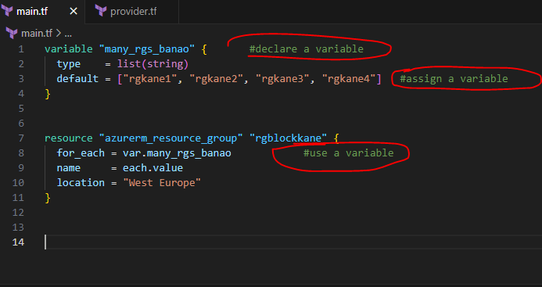

**terraform plan**

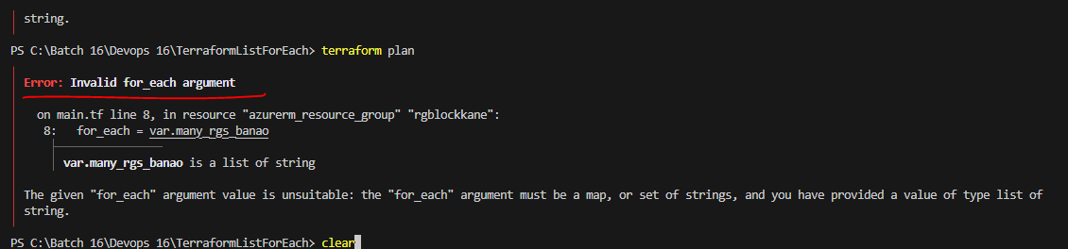

So while doing from list it is giving us the error

Now we will use terraform function

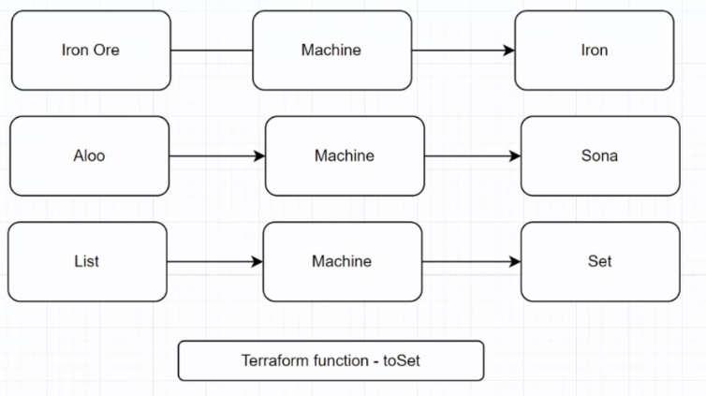

2) **SEARCH – Terraform functions**

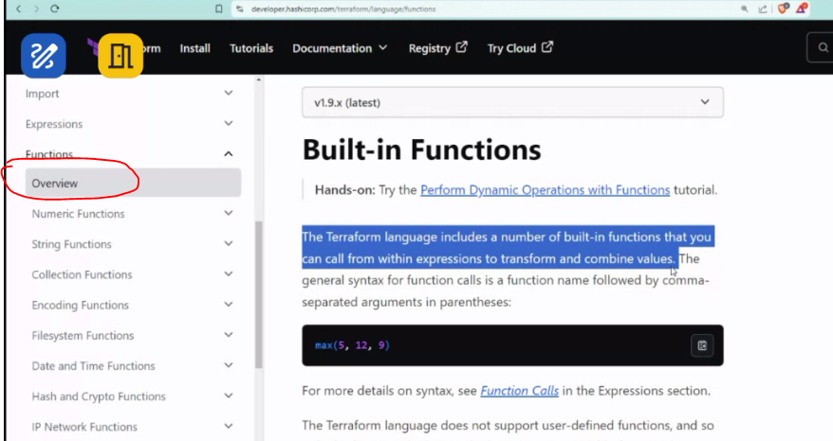

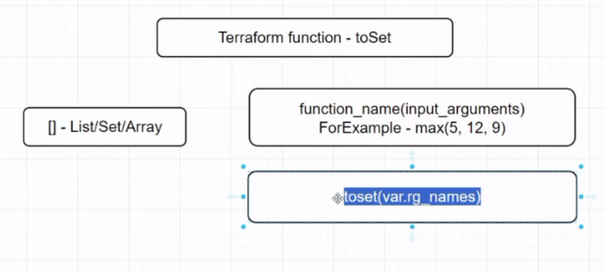

3)

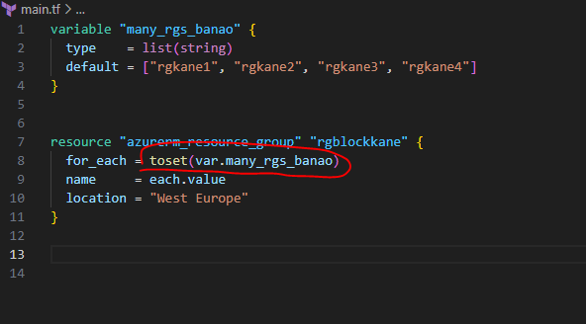

4) For each and count – 2 types of loops are there in terraform and both are known as **Meta arguments**

5) Whatever we write below resource group are known as **meta arguments**

6) For each – Best method of coding

7) What do you understand by meta arguments in terraform?

Used for looping

**++++++++++++++++++++++++++++++++++++++++++++++++++++++++++++++++++++++++++**

**DRAWBACKS OF LISTS**

1) In list, terraform does not allow to create rgs like rg1, rg2, rg3, rg4 in different locations. So to overcome this problem we will use map

**++++++++++++++++++++++++++++++++++++++++++++++++++++++++++++++++++++++++++**